ATIKA GREENE
SAG-AFTRA-E
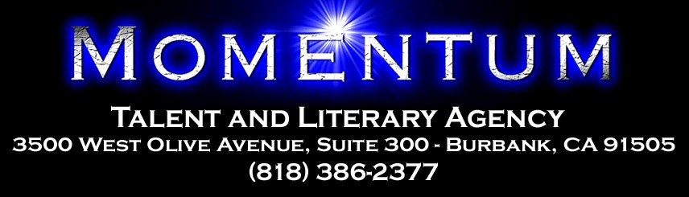

FILM/TELEVISION
Insecure | CO-STAR | HBO, Dir: Tina Mabry
Stiletto Dreams | LEAD | Dir: James M. Perry
Lost In The Tide | LEAD | Dir: Tari Wariebi
Pocket | LEAD | Dir: Deonna ‘Tree’ Young

INTERNET
Mistake PRINCIPAL Kweli TV, Dir: Nicolette Ellis
Coming Home | PRINCIPAL | Dope Ego TV, Dir: Brittany Coleman
Fearless  Tough Love | PRINCIPAL  GUEST STAR | Tik Tok, Dir: James Henry  Tv One, Dir: Roni Simpson

THEATRE
A Time To Kill | GWEN HAILEY | Theatre 68, Los Angeles
Gods Waiting Room | NURSE SHONDRA | Matrix Theatre, Los Angeles
A Raisin In The Sun | RUTH | Liberty Theatre, New Jersey
My Brothers A Keeper | CHARLENE | New York University, New York

COMMERCIAL
LIST AVAILABLE UPON REQUEST

TRAINING
SCRIPT ANALYSIS K.C. CLYDE
COMEDY INTENSIVE LESLY KAHN
ON-CAMERA CLASS | AMY LYNDON
COMMERCIAL AUDITION | MIKE POINTER
BA THEATRE ARTS | CHEYNEY UNIVERSITY OF PENNSYLVANIA
ACTING | AMERICAN MUSICAL & DRAMATIC ACADEMY

SPECIAL SKILLS
DIALECTS: WEST INDIAN (JAMAICAN), BROOKLYN, SOUTHERN, BRITISH
SPORTS: SOFTBALL (1ST BASE, 2ND BAST, OUTFIELD), KARATE, SHOTOKAN, TAE KWON DO, BOXING, STAGE COMBAT (UNARMED, RAPIER+DAGGER, SINGLE RAPIER, BROADSWORD, QUARTERSTAFF)
VOICE: ALTO BARKING LIKE A DOG!

